Name : Sundara Moorthy
Reg No : 192324228
Course code : Cloud Computing And Big Data Analysis
Exp No : EXPERIMENT 12
Date : !8/12/2025

EXPERIMENT 12
Title
Demonstration of Virtualization by Installing a Type-2 Hypervisor and Creating a Virtual Machine using VMware Workstation

Aim
To demonstrate virtualization by installing a Type-2 Hypervisor (VMware Workstation) on a host machine and creating, configuring, and running a virtual machine with a guest operating system (Windows/Linux).

Procedure
- Download VMware Workstation from the official VMware website.
- Install VMware Workstation on the host operating system (Windows/Linux).
- Launch VMware Workstation after successful installation.
- Select Create a New Virtual Machine.
- Choose the installer disk image file (ISO) of the guest operating system.
- Configure virtual machine settings such as:
  - Virtual CPU
  - Memory (RAM)
  - Storage (Virtual Hard Disk)
  - Network Adapter
- Complete the virtual machine creation wizard.
- Start the virtual machine.
- Install the guest operating system inside the virtual machine.
- Verify successful virtualization by accessing the guest OS within VMware Workstation.

Sample Configuration Details
• Host Operating System: Windows 10
• Hypervisor: VMware Workstation
• Guest Operating System: Ubuntu Linux / Windows 10
• RAM Allocated: 4 GB
• Virtual Hard Disk: 40 GB
• Processor: 2 Virtual CPUs

Output
• VMware Workstation successfully installed on host system.
• Virtual Machine created and configured with selected resources.
• Guest operating system installed and running inside the virtual environment.
• Host and guest operating systems running simultaneously, demonstrating virtualization.
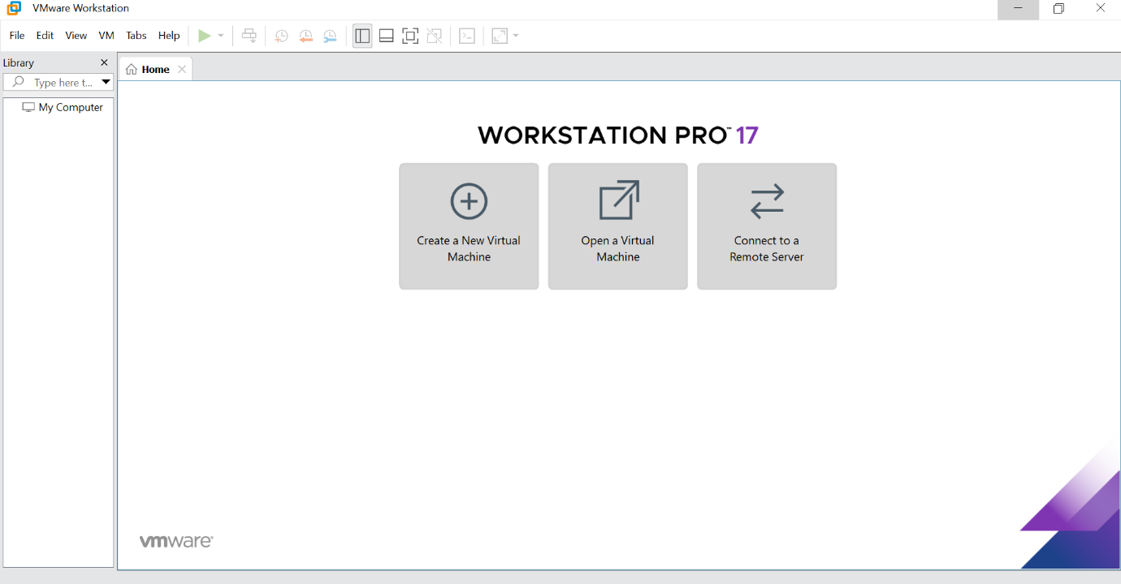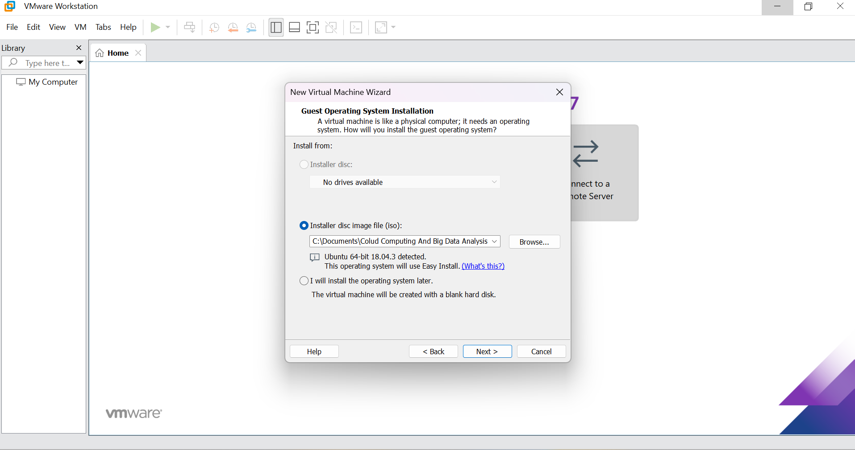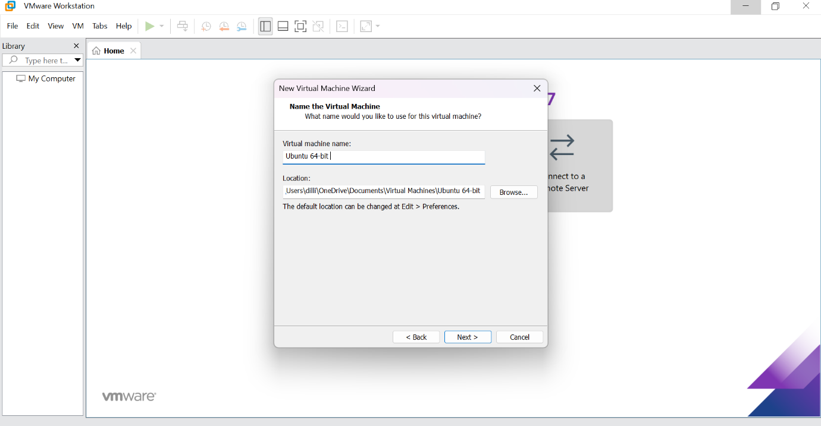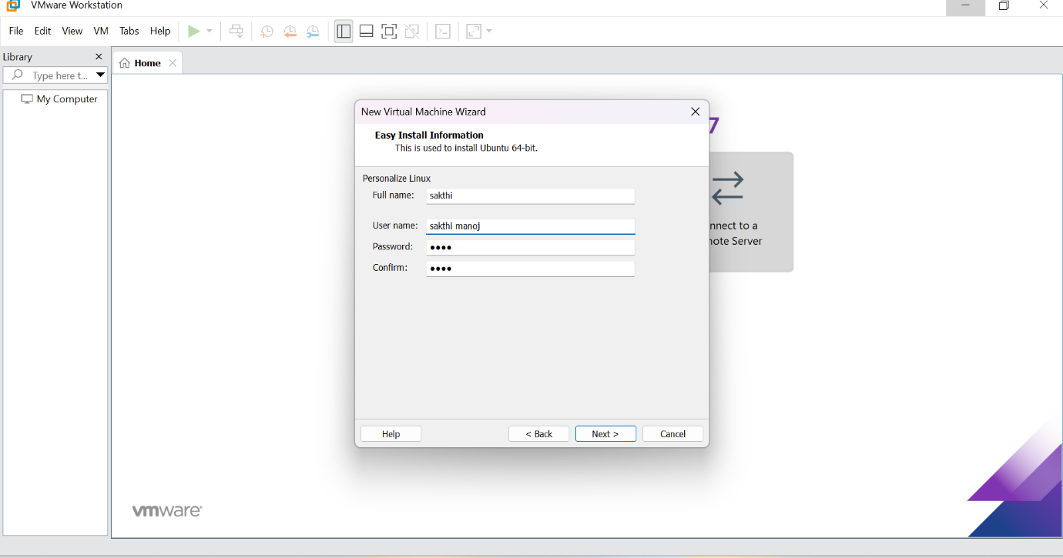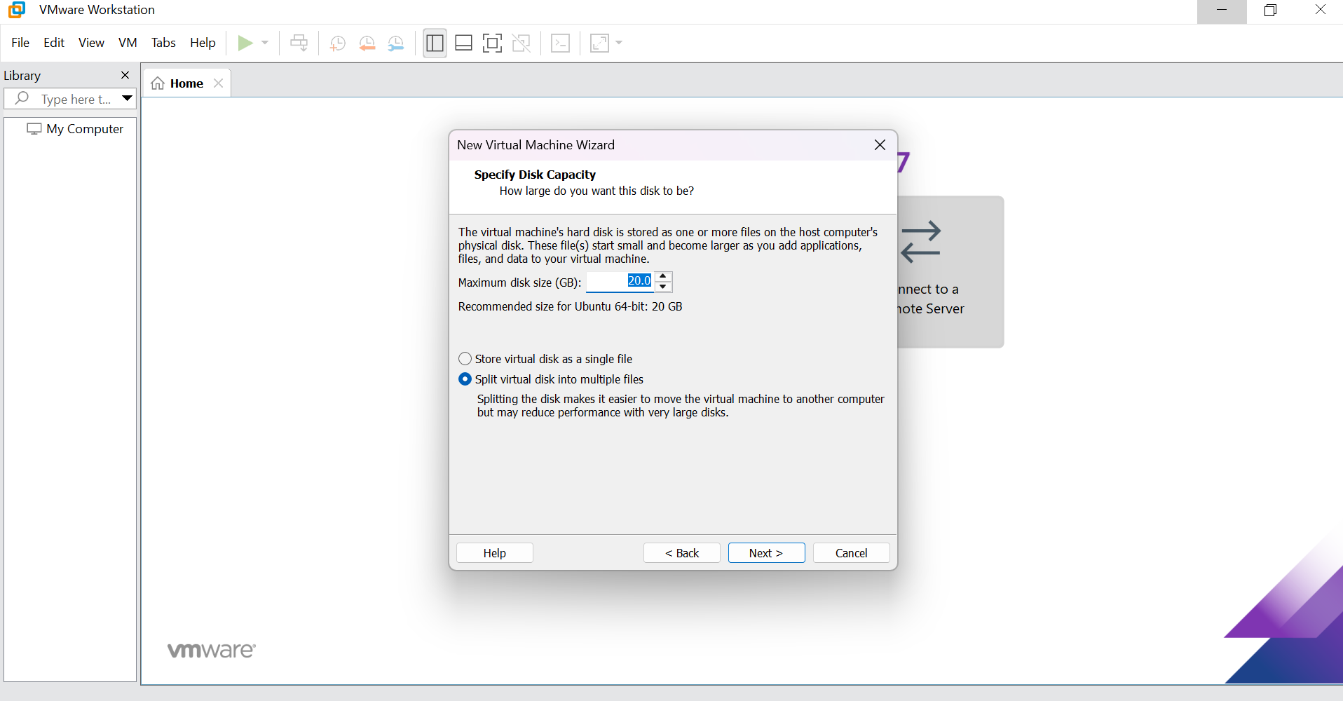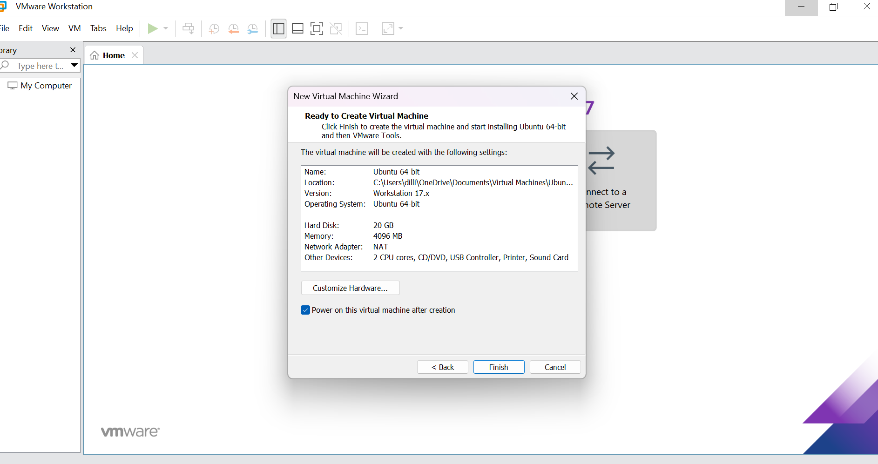
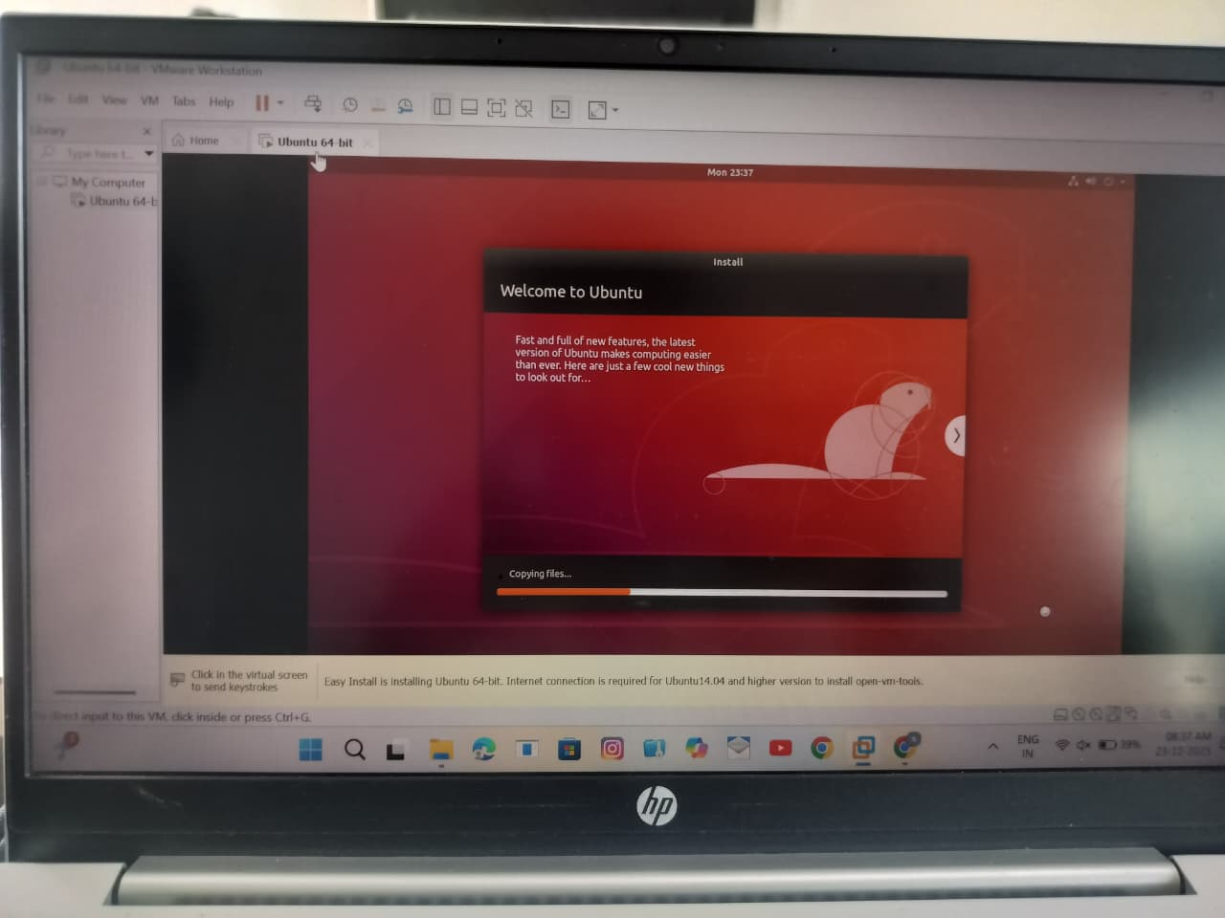

Result
Thus, virtualization was successfully demonstrated by installing a Type-2 Hypervisor (VMware Workstation) and creating and configuring a virtual machine with a guest operating system.

